Unit 2 - Exponential & Logarithmic Functions
2.1 Change in Arithmetic and Geometric Sequences

Sequence:

Example 1: Consider the sequence defined by $a_{n}=4n-3$. Find $a_{0}$ and $a_{7}$.

 | Arithmetic Sequences | Geometric Sequences
Properties
Formulas
Example | 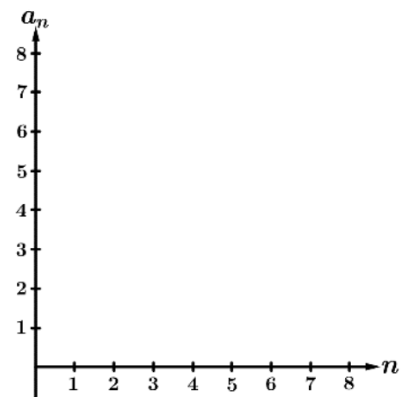 | 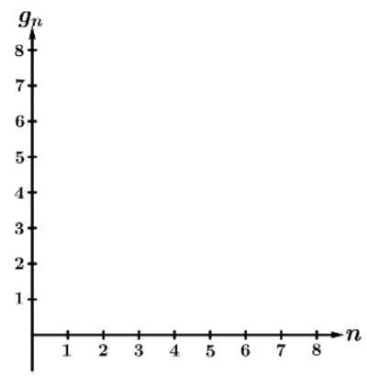

Example 2: For each of the following, determine if the sequence could be arithmetic, geometric, or neither. If arithmetic, identify the common difference. If geometric, identify the common ratio.
- $s_{n}=n^{2}-3$ | - $s_{n}=6-2n$ | - -7, -2, 3, 8, 13, … | - 1, -2, 3, -4, 5
- $s_{n}=4(2)^{n-1}$ | - 1, 3, 2, 6, 4, 12, 8,... | - $s_{n}=3n^{2}$ | - 16, -8, 4, -2, 1

Example 3. Let $a_{n}$ be an arithmetic sequence with a common difference of -3 and $a_{3}=8$. Find an expression for $a_{n}$, and use the expression to find $a_{12}$.

Example 4. Let $a_{n}$ be an arithmetic sequence with $a_{2}=7$ and $a_{6}=9$. Find $a_{24}$.

Example 5. Several terms of the arithmetic sequence $a_{n}$ are shown below. Find an expression for $a_{n}$ and use the expression to find $a_{17}$.
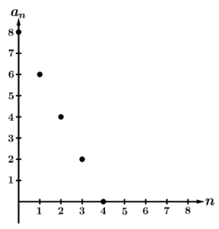

Example 6. Let $g_{n}$ be a geometric sequence with a common ratio of 2 and $g_{1}=12$ . Find an expression for $g_{n}$ and use the expression to find $g_{4}$.

Example 7. Several terms of the geometric sequence $g_{n}$ are shown below. Find an expression for $g_{n}$ and use the expression to find $g_{10}$.
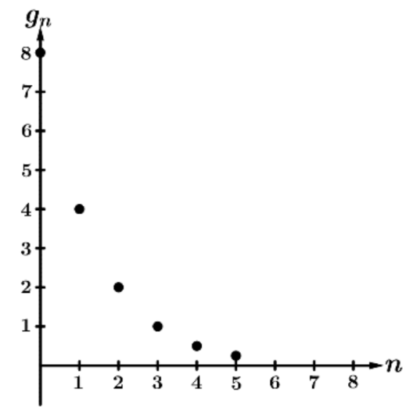

Example 8. Let $g_{n}$ be a geometric sequence with $g_{3}=-2$ and $g_{6}=128$ . Find an expression for $g_{n}$ and use the expression to find $g_{11}$.

Example 9. Let $g_{n}$ be a geometric sequence with $g_{2}=48$ and $g_{7}=1.5$ . Find an expression for $g_{n}$ and use the expression to find $g_{11}$.

Unit 2 - Exponential & Logarithmic Functions
2.2 Change in Linear & Exponential Functions

Linear Functions | Exponential Functions
$f(x)=b+mx$  Over equal-length input-value intervals, the output  values change at a _________________________  The change in $y$ is based on ___________________ | $f(x)=ab^{x}$  Over equal-length input-value intervals, the output  values change _______________________  The change in $y$ is based on ___________________

Example 1: Selected values of several functions are given in the table below. For each table, determine if the function could be linear, exponential or neither. Give a reason for your answer.
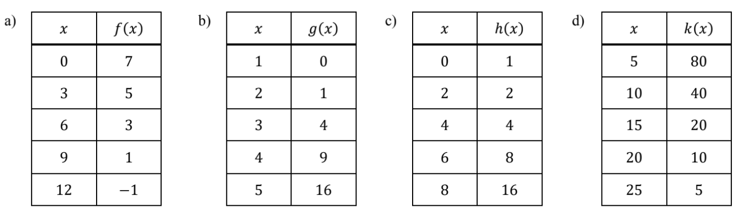

Example 2: Calculator Active. A wild rumor is spreading that Luke won 3rd place in the World’s Strongest Man Contest. The number of people that have heard the rumor can be modeled by using a geometric sequence, where 43 people have heard the rumor on day 3 and 140 people have heard the rumor on day 6. According to the model, how many people, to the nearest whole number, have heard the rumor by day 10?

Example 3: A large theater has rows of seats where the number of seats in each row can be modeled by an arithmetic sequence. If the fifth row has 31 seats and the eleventh row has 49 sets, determine how many seats there are in the 25th row.

Unit 2 - Exponential & Logarithmic Functions
2.3 Exponential Functions

Key Characteristics of Exponential Functions

Example 1: For each…
- Write limit statements for end behavior.
- What can you conclude about the values of $a$ and $b$?
- What can you conclude about increasing/decreasing or concave up/down?

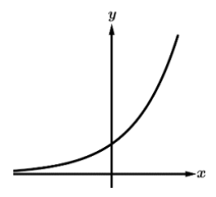 | 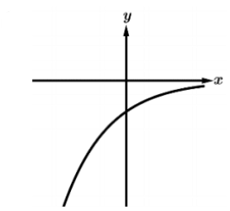 | 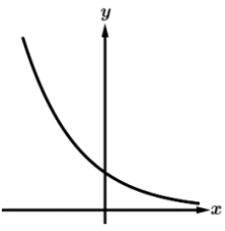
- $g(x)=5(\frac{2}{3})^{x}$ | - $h(x)=3(4)^{x}$ | 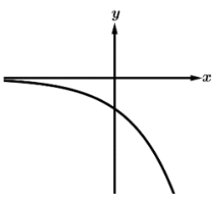

Example 2. The following values are output values of an exponential function of the form $f(x)=ab^{x}$ where $a$ and $b$ are constants. Write the function along with the input value that represents the output value.
- $4∙4∙4∙1.5$ | - $0.8∙3.2∙0.8$

Example 3. Multiple Choice Question. The exponential function $f$ is defined by $f(x)=ab^{x}$, where $a$ and $b$ are positive constants. The table gives values of $f(x)$ at selected values of $x$. Which of the following statements is true?
$x$ | $0$ | $1$ | $2$ | $3$ | $4$
$f(x)$ | $40$ | $20$ | $10$ | $5$ | $\frac{5}{2}$

- $f$ demonstrates exponential decay because $a>0$ and $0<b<1$
- $f$ demonstrates exponential decay because $a>0$ and $b>1$
- $f$ demonstrates exponential growth because $a>0$ and $0<b<1$
- $f$ demonstrates exponential growth because $a>0$ and $b>1$

Example 4. Multiple Choice Question. The function $h$ is a function of the form $h(x)=ab^{x}$, where $a≠0$ and $b>1$. The function $h$ is also given by $h(x)=f(x)+2$. Which of the following statements is true?

- The output values of both $f$ and $h$ are proportional over equal-length input value intervals.
- The output values of both $f$ only, not $h$, are proportional over equal-length input value intervals.
- The output values of both $h$ only, not $f$, are proportional over equal-length input value intervals.
- The output values of neither $f$ nor $h$ are proportional over equal-length input value intervals.

Unit 2 - Exponential & Logarithmic Functions
2.4 Exponential Function Manipulation

Product Property  $b^{m}b^{n}=b^{m+n}$  Examples: $x^{5}x^{3}=$  $2^{x}2^{3}=$ | Power Property  $(b^{m})^{n}=b^{mn}$  Examples: $(x^{5})^{3}=$  $(2^{x})^{3}=$ | Negative Exponent Property  $b^{-n}=\frac{1}{b^{n}}$  Examples: $x^{-3}=$  $2^{-x}=$

Example 1: Each of the following exponential functions has a horizontal translation. For each, write an equivalent representation that has a vertical dilation and no horizontal translation.
- $f(x)=4^{x+2}$ | - $k(x)=5^{x-1}$ | - $g(x)=4(3)^{x+2}$

Example 2: For each, write an equivalent representation.
- $g(x)=2^{3x}$ | - $h(x)=9^{x/2}$

Example 3: Multiple Choice. Which of the following functions is an equivalent form of the function $y=9^{2x}$?
- $f(x)=3^{x}$
- $f(x)=3⋅9^{x}$
- $f(x)=18^{x}$
- $f(x)=81^{x}$
Example 4: Multiple Choice. Which of the following functions is an equivalent form of the function $y=9⋅4^{x}$?
- $f(x)=3⋅16^{x/2}$
- $f(x)=3⋅16^{2x}$
- $f(x)=9⋅16^{x/2}$
- $f(x)=9⋅16^{2x}$

Unit 2 - Exponential & Logarithmic Functions
2.5 Exponential Context & Data Modeling

Example 1: Selected values from several exponential functions are given in the tables below. For each,find the constant value that can be added/subtracted to the output values to reveal a proportional growth pattern. Then, write an equation to model the function.
  $x$ | $f(x)$
  0 | 7
  1 | 13
  2 | 25
  3 | 49
  4 | 97
  $x$ | $g(x)$
  0 | 2
  1 | 10
  2 | 34
  3 | 106
  4 | 322
  $x$ | $h(x)$
  0 | 63
  1 | 31
  2 | 15
  3 | 7
  4 | 3
Example 2: Calculator Active. For $0≤t≤30$ minutes, the number of fans inside a large sports stadium can be modeled by the exponential function $F(t)=a(b)^{t}$ where $F$ represents the number of fans inside the stadium $t$ minutes after the doors open. There are 47 people in the stadium 2 minutes after the doors open, and there are 2602 fans inside the stadium 20 minutes after the doors open.

  - Use the given data to write two equations that can be used to find the values for constants $a$ and $b$ in the expression $F(t)$.
  - Find the values for 𝑎 and 𝑏, then write the expression for $F(t)$

  - Use the given data to find the average rate of change of the number of fans in the stadium from $t=2$ to $t=20$ minutes. Show the computations that lead to your answer.
  - Interpret the meaning of your answer from part (i) in the context of the problem.
- Use the average rate of change found in part b to estimate the number of fans in the stadium, at time $t=3$ minutes. Show the work that leads to your answer.
- Does the model found in part (a) demonstrate exponential growth or exponential decay? Give a reason for your answer.
Example 3: The number of bacteria $B$ in a particular culture can be modeled by the exponential function $B(t)=17e^{0.31t}$, where $t$ is measured in hours.
- Let $A(t)=a⋅b^{t}$ be an equivalent expression for $B(t)$. Find the value of $b$.
- Find the average rate of change of $B(t)$ over the interval from $t=1$ to $t=7$ hours.
- Find the number of bacteria $B$ predicted by the model after 15 hours.
Example 4: After 50 deer were introduced to a large wooded area, the population of deer in the wooded area can be modeled by the exponential function $D(t)=a⋅b^{t}$, where $t$ represents the number of years since deer were first introduced to the wooded area. The population of deer increases by 13% each year.
- Find the values of $a$ and $b$, and use these values to write an expression for $D(t)$.
- According to the model found in part (a), what is the population of deer in the large wooded area after 6 years?
- Find an equivalent expression for $D(t)$ where $t$ is measured in months.

Unit 2 - Exponential & Logarithmic Functions
2.6 Competing Function Model Validation

Example 1: Selected values from several functions are given in the tables below. Use technology and your knowledge of functions to determine if a linear, quadratic, or exponential model is most appropriate.
  $x$ | $f(x)$
  0 | 11
  2 | 8.2
  4 | 5
  6 | 2.3
  8 | -1
  $x$ | $g(x)$
  -1 | 2
  1.5 | 5.5
  4 | 10.5
  6.5 | 5.75
  9 | 2.25
  $x$ | $h(x)$
  1 | 10
  3 | 5.2
  5 | 2.4
  7 | 1.3
  9 | 0.7
  $x$ | $k(x)$
  -2 | 2
  1 | 3
  4 | 4.5
  7 | 6.75
  10 | 10.25

Residuals:

Example 2: The weight of newborn babies can be modeled by a linear function for the first four months after birth. Selected values for the weight $W(t)$, in kilograms, in kilograms, of a particular newborn baby are given in the table below, where $t$ represents the number of months since birth.
$t$ | 0 | 1 | 2 | 3 | 4
$W(t)$ | 3.2 | 4.2 | 5.1 | 5.8 | 6.4
- Use the regression capabilities on your calculator to find a linear model of the form $y=a+bx$ for the weight (in kilograms) of this particular baby $x$ months after birth.
- Use the model found in part (a) to predict the weight (in kg) of this baby 2.5 months after birth.
- The actual weight of this baby 2.5 months after birth was 5.5 kilograms. What is the residual for this weight? Did our model underestimate or overestimate the weight of this baby 2.5 months after birth?
Using a Residual Plot to Check the Appropriateness of a Model:

Example 3: An exponential regression was used to model a data set. The residual plot for the exponential regression model is shown above. Which of the following is the best conclusion about the appropriateness of the exponential regression model based on the corresponding residual plot?
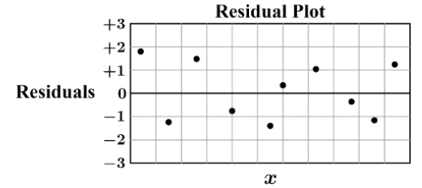
- The exponential model is not appropriate because the residuals show no pattern.
- The exponential model is not appropriate because the residuals show a pattern.
- The exponential model is appropriate because the residuals show no pattern.
- The exponential model is appropriate because the residuals show a pattern.

Example 4: A group of AP Precalculus students used a set of data to create linear, quadratic, and exponential regression models. After creating the three models, the students created a residual plot for each model type (see above). Based on the three residual plots below, which model was most appropriate for the data? Give a reason for your answer based on the residual plots below.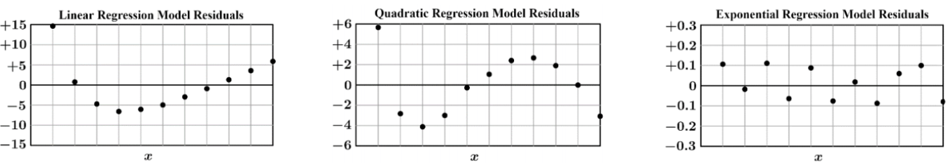

Unit 2 - Exponential & Logarithmic Functions
2.7 Compositions of Functions

Example 1: The functions $f$ and $g$ are defined by $f(x)=3x+5$ and $g(x)=2x+1$. Evaluate the following.
- $f(g(3))$ | - $g(f(3))$ | - $(f∘f)(2)$
- $f(g(x))$ | - $(g∘f)(x)$ | - $(g∘g)(x)$

Example 2: The functions $h,k,p$ and $m$ are given below. Use these functions to find the following.
$h(x)=2x-3$ $k(x)=x^{2}+4x+5$ $m(x)=3x+2$

- $k(h(4))$ | - $(h∘m)(-2)$ | - $(k∘m)(x)$

Example 3: Calculator Active. The figure below shows the graph of the function $f$ on its domain $0≤x≤9$. The function $g$ is given by $g(x)=1.2x^{3}-4.7x+9.62$. The function $h$ is defined by $h(x)=(g∘f)(x)=g(f(x))$. Find the value of $h(6)$ as a decimal approximation or indicate that it is not defined.
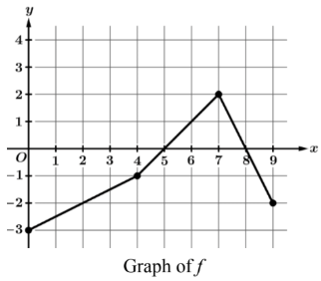
Example 4: The graph of the function $f$ is given below along with a table of selected values for the function $g$, an equation of the piecewise function $h$, and a verbal description of the function $k$. Use this information to evaluate the following, if possible.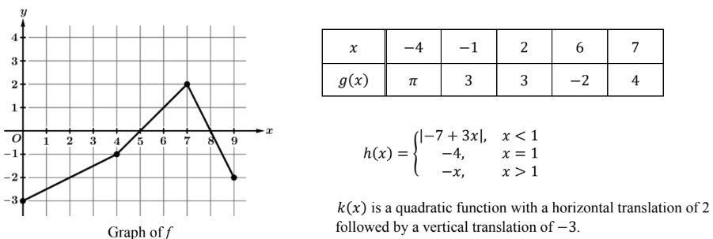

- $f(g(7))$ | - $(g∘f)(7)$ | - $(h∘k)(0)$
- $f(f(8))$ | - $(g∘h)(1)$ | - $(g∘k)(-1)$

Example 5: Multiple Choice. The table gives values for the functions $f$ and $g$ at selected values of $x$. Functions $f$ and $g$ are defined for all real numbers. Let $h$ be the function defined by $h(x)=f(g(x))$. What is the value of $h(1)$?
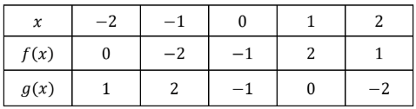
- $-2$
- $-1$
- $0$
- $2$

Example 6: Multiple Choice. The function $f$ is given by $f(x)=x^{2}-3x+7$, and the function $g$ is given by $g(x)=3x+5$. Which of the following is an expression for $f(g(x))$?
- $3x^{2}-9x+26$
- $9x^{2}+21x+17$
- $9x^{2}+27x+32$
- $3x^{3}-4x^{2}+6x+35$

Unit 2 - Exponential & Logarithmic Functions
2.8 Inverse Functions

Example 1: Find the inverse relation of the given table. Is the original relation a function? Is the inverse relation a function?
$x$ | $1$ | $3$ | $4$ | $6$
$y$ | $-1$ | $2$ | $0$ | $2$

Example 2: Sketch the inverse relation of each graph. Is the original relation a function? Is the inverse relation a function?
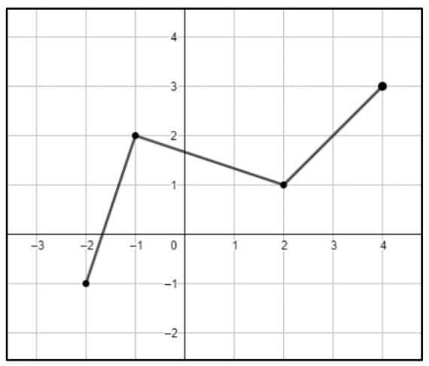 | 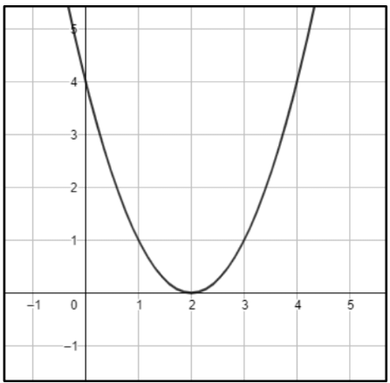 | 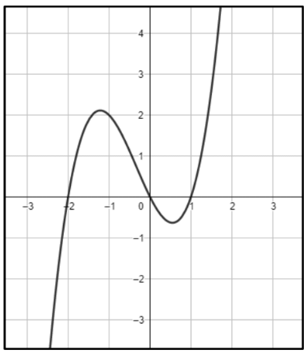

Example 3: Find the inverse of $g(x)=\frac{2x+1}{x-3}$ given that $x≠3$ and $x≠2$

Using Compositions to Prove Inverse Functions:

Example 4: Let $f(x)=2x-3$ and $g(x)=\frac{1}{2}x+\frac{3}{2}$. Use compositions of functions to determine if $f(x)$ and $g(x)$ are inverses.

Example 5: Let $h(x)=x^{2}+10$.
- Restrict the domain of $h(x)$ so that $h(x)$ is invertible.
- Let $h^{-1}(x)=k(x)$. Find an equation for $k(x)$.

- Use compositions of functions to prove that $h(x)$ and $k(x)$ are inverses.

Example 6: Let $n(x)=\frac{6}{x-4}$.
- Restrict the domain of $n(x)$ so that $n(x)$ is invertible.
- Let $n^{-1}(x)=p(x)$. Find an equation for $p(x)$.
- Use compositions of functions to prove that $n(x)$ and $p(x)$ are inverses.

Example 7: Let $f$ be a continuous function with selected values in the table below. Let $g$ be the inverse of $f$, such that $g(x)=f^{-1}(x)$. Find the following values if possible.
$x$ | $-3$ | $-2$ | $0$ | $1$ | $4$ | $6$
$f(x)$ | $6$ | $3$ | $1$ | $-1$ | $-3$ | $-7$

- $f(f(0)$ | - $g(-3)$ | - $g(6)$
- $g(g(-1))$ | - $(f^{-1}∘f)(-2)$ | - $f^{-1}(-3)$
Example 8: The function $k$ is defined over the interval $-4≤x≤11$ are shown below. Let $k^{-1}$ represent the inverse of $k$.
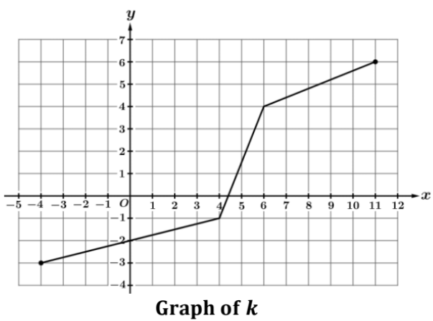 | - What is the minimum value of $k(x)$? What is the minimum value of $k^{-1}(x)$?  - Find $k^{-1}(6)$ and $k^{-1}(4)$.

Example 9: The function $f$ is defined over the interval $-2≤x≤8$ as shown in the graph below. Let $f^{-1}$ represent the inverse of $f$.
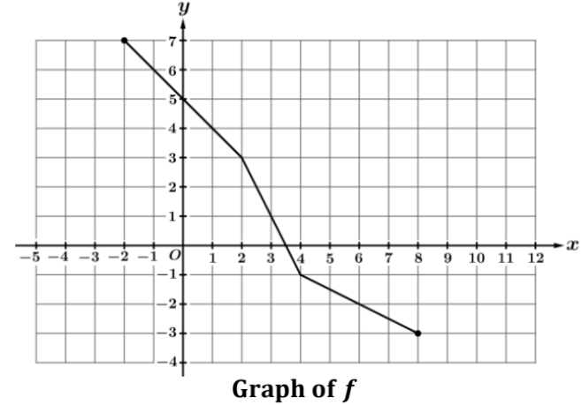 | - What is the maximum value of $f^{-1}(x)$?  - Find $f^{-1}(3)$ and $f^{-1}(1)$.  - What is the domain of $f^{-1}$?
Example 10: The function $g$ is defined over the interval $-3≤x≤10$ as shown below. Let $g^{-1}$ represent the inverse of $g$. Values of the increasing function $h$ are given in the table below for selected values of $x$. Evaluate the following, if possible.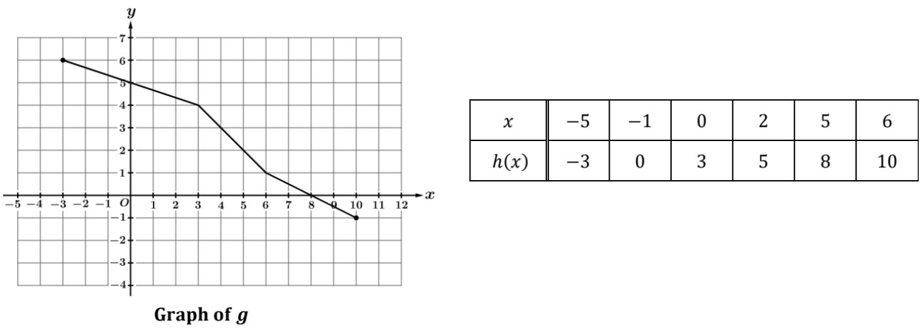
- $g(h(6))$ | - $g^{-1}(h(0))$
- $h^{-1}(g(8))$ | - $h^{-1}(g^{-1}(-1))$

Unit 2 - Exponential & Logarithmic Functions
2.9 Logarithmic Expressions & 2.10 Inverses of Exponential Functions

Example 1: Evaluate the following without a calculator.
- $log_{2}8$ | - $log_{5}25$ | - $log_{2}32$ | - $log100$
- $log_{16}4$ | - $log_{3}1$ | - $log10$ | - $log_{6}\frac{1}{36}$

Using a Logarithmic Scale:

The population of English Americans in the (current) United States since 1620 has grown exponentially. The estimated population is shown below from 1620–1820, where $t=0$ represents the year 1620.
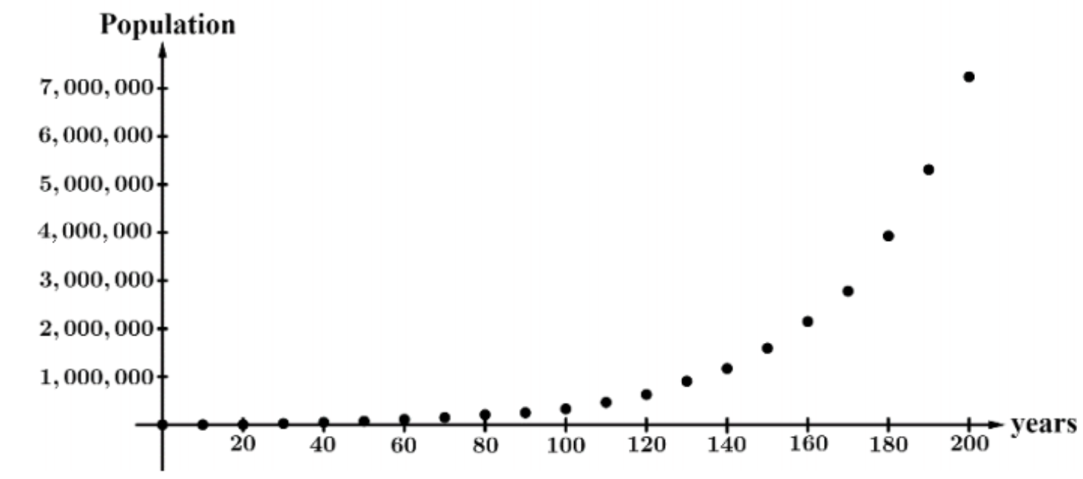

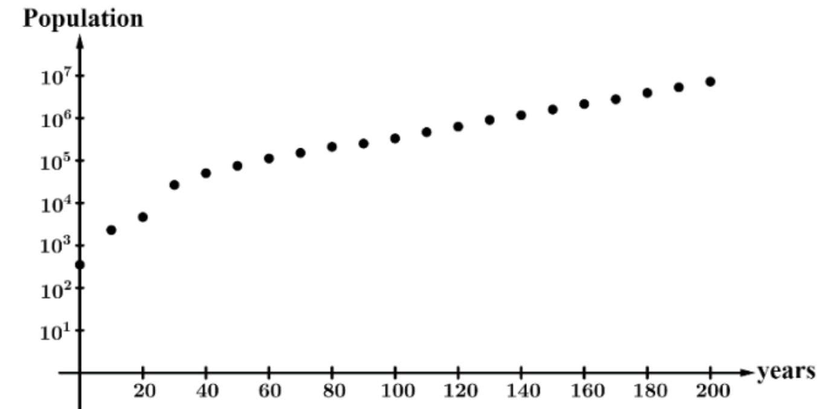

Example 2: The population data of English Americans in the current United States for the years 1840, 1860, and 1880 are given below. Plot these additional data points on the graph above.

Year | $1840$ | $1860$ | $1880$
Population | $17,069,453$ | $31,443,321$ | $50,189,209$

Example 3: One common type of graph with a logarithmically scaled vertical axis includes gridlines as seen below. Plot the following points on the coordinate plane below.
A $(1,20)$ B $(2, 300)$ C $(3,2)$ D $(4, 15)$ E $(5, 350)$
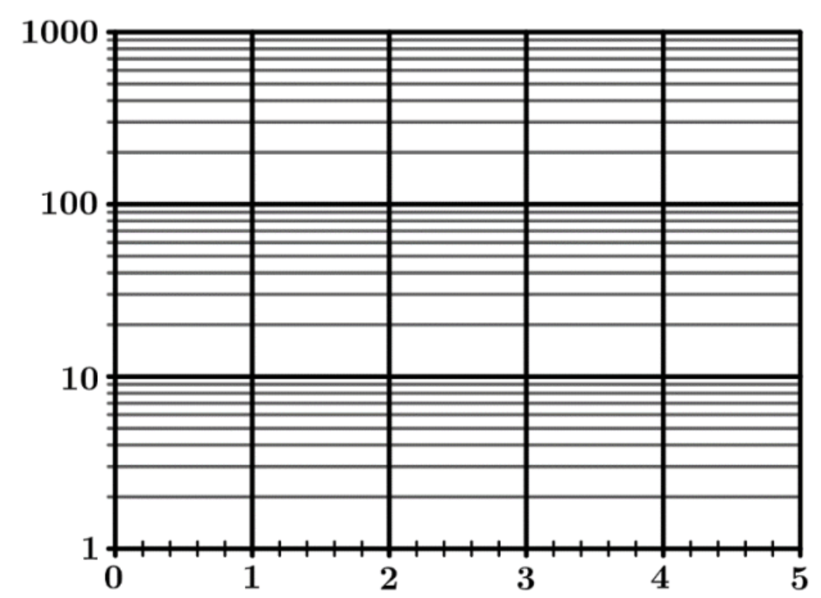

Example 4: Let $f(x)=3^{x}$ and $g(x)=log_{3}x$. Use compositions of functions to show that $f$ and $g$ are inverse functions.

Example 5: Let $k(x)=2^{x}$. Find $k^{-1}(x)$, the inverse of $k(x)$. Then, sketch $k(x)$ and $k^{-1}(x)$ on the same coordinate plane.
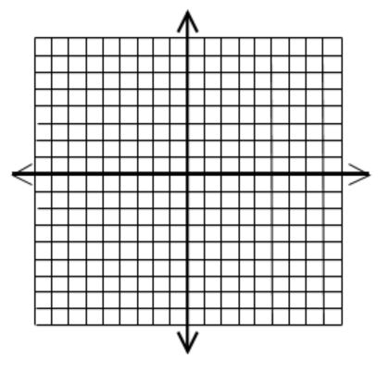

Example 6: The exponential function $h(x)=a^{x}$ contains the points $(2,3)$ and $(6,27)$. Find the average rate of change of $y=log_{a}x$ over the interval $[3,27]$.

Example 7: Find the inverse function.
- $f(x)=\frac{e^{x^{1/4}}}{4}$ | - $f(x)=8^{\frac{\sqrt[5]{x-9}}{5}}$
- $f(x)=\sqrt[4]{6^{x+5}}$ | - $f(x)=(4\sqrt[4]{x})^{5}-3$
- $f(x)=2^{\frac{x-10}{8}}$ | - $f(x)=ln(\sqrt[7]{9x}-6)$
- $f(x)=log_{5}(\frac{x^{5}}{3})+4$ | - $f(x)=\frac{\sqrt[3]{6^{x}}}{5}$

Unit 2 - Exponential & Logarithmic Functions
2.11 Logarithmic Functions

A logarithmic function has the general form $f(x)=alog_{b}x$ where $b>0$ and $a≠0$ and $b≠1$.
$0<b<1$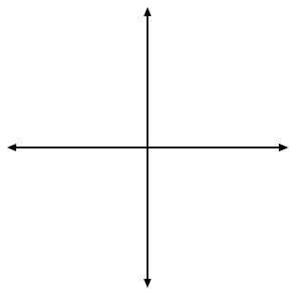  Domain:  Range:  Increasing:  Decreasing:  Concave Up:  Concave Down:  End Behavior:  Asymptote: | $b>1$  Domain:  Range:  Increasing:  Decreasing:  Concave Up:  Concave Down:  End Behavior:  Asymptote:

Example 1: Write as much information as possible about each function below.
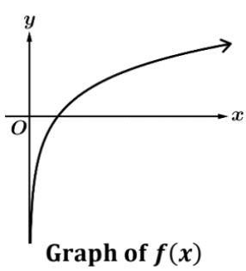 | - 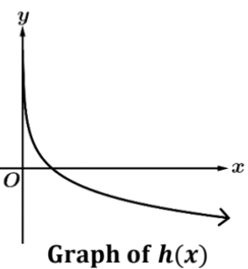
- $g(x)=2log_{3}x$ | - $h(x)=5log_{1/2}x$
- $f(x)=-4log_{6}x$ | - $p(x)=-\frac{1}{2}log_{1/3}x$

For logarithmic functions, the input values change ________________________ while the output values change __________________.

Example 2: Selected values for several functions are shown below. For each, determine if the given function could be logarithmic, exponential, or neither.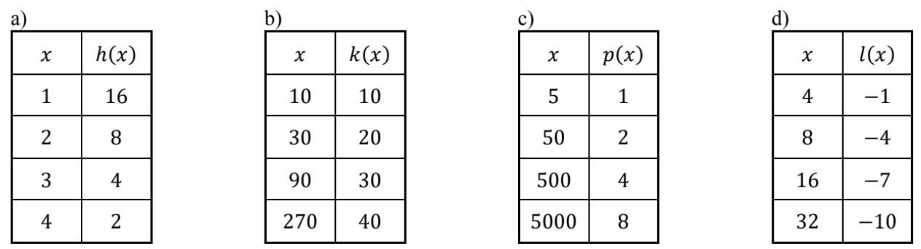

Example 3: Selected values of several logarithmic functions are shown in the tables below. For each, find the value of the constant $k$.
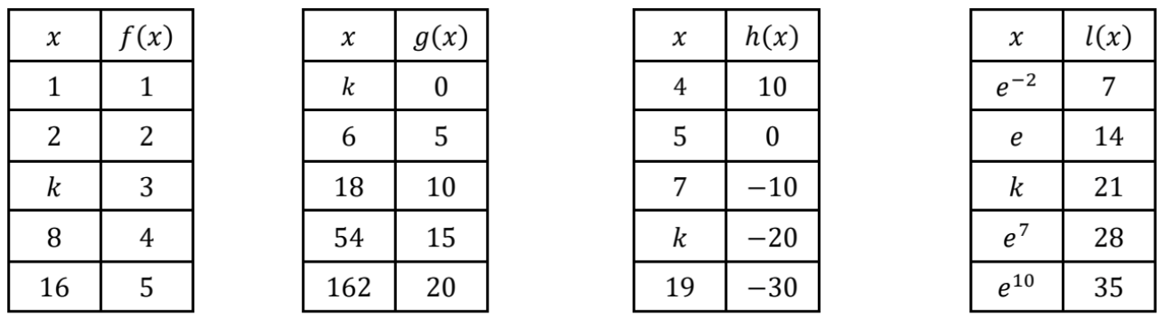

Example 4: For each, sketch a graph. State the domain, range, asymptotes, end behavior.
- $f(x)=log_{3}(x+1)$ | - $g(x)=-5log_{2}(x-3)$
- $h(x)=8log(2x+3)$ | - $k(x)=2log_{3}(-x+2)$
- $a(x)=ln(4-x)+2$ | - $f(x)=-log_{1/2}x$

Unit 2 - Exponential & Logarithmic Functions
2.12 Logarithmic Function Manipulation

Product Property  $log_{b}(xy)=log_{b}(u)+log_{b}(v)$  Example:  $log_{2}(5x)=$ | Quotient Property  $log_{b}(\frac{x}{y})=log_{b}x-log_{b}y$  Example:  $log_{3}(\frac{y}{4})=$ | Power Property  $log_{b}u^{n}=nlog_{b}u$  Example:  $log_{7}3^{x}=$

Example 1: For each of the following, write an equivalent expression by condensing each expression to a single logarithm.
- $log_{4}x-log_{4}5-log_{4}z$ | - $2+log_{6}x$
- $2log_{7}a-5log_{7}b+log_{7}4$ | - $-\frac{1}{2}lnx+2lny-\frac{1}{3}lnz$
- $\frac{1}{2}[\frac{1}{5}log_{2}x+log_{2}y]-3log_{2}z$ | - $3+\frac{1}{2}log_{4}x+\frac{1}{2}log_{4}y$

Example 2: Multiple Choice. Which of the following expressions is equivalent to $log_{3}(\frac{x^{2}}{y})$?
- $log_{3}(2x)-log_{3}y$
- $2(log_{3}x-log_{3}y)$
- $2log_{3}x-log_{3}y$
- $log_{3}x+log_{3}2-log_{3}y$

Example 3: Multiple Choice. Which of the following expressions is equivalent to $3ln(x)-4ln(y)$?
- $ln(\frac{x^{3}}{y^{4}})$
- $ln(\frac{3x}{4y})$
- $ln(x^{3}-y^{4})$
- $ln(3x-4y)$
Example 4: For each, the function $f(x)$ is a horizontal dilation of the function $g(x)$. Show that $f$ can also be written as a vertical translation of $g$, with $f(x)=g(x)+k$, where $k$ is a constant.
- $f(x)=log(6x)$, $g(x)=log(x)$ | - $f(x)=log_{2}(8x)$ and $g(x)=log_{2}x$
- $f(x)=log_{2}(\frac{x}{8})$ and $g(x)=log_{2}x$ | - $f(x)=\frac{5^{x}}{25}$ and $g(x)=5^{x}$

Change of Base Property
$log_{b}x=\frac{log_{a}x}{log_{a}b}$ where $a>0$ and $a≠1$

Example 6 : Show that $log_{8}1000=log_{2}10$ algebraically.
Example 7: Let $f(x)=log_{4}x$ and $g(x)=log_{9}x$. Show that $f$ is a vertical dilation of $g$ by finding the value of $k$ such that $f(x)=k∙g(x)$.

Unit 2 - Exponential & Logarithmic Functions
2.13 Exponential & Logarithmic Equations

Example 1: Solve the following equations Check for extraneous solutions when necessary.
- $4^{x}-2=7$ | - $2^{x+3}+5=26$
- $-7=3-4e^{x}$ | - $2log_{3}(x+3)+4=10$
- $2+log_{5}(2x-1)=4$ | - $\frac{ln(2-x)}{5}=1$
- $log(3)+log(x+4)=log(5x-2)$ | - $ln(x+1)-ln(3x-5)=ln(7)$
- $log_{3}(x+2)+log_{3}(x-3)=log_{3}14$ | - $ln(x)-ln(3)=2$
- $log_{4}(x)-3log_{4}2=log_{4}(x+7)$ | - $log(x)-2=log(x-7)$
- $2^{x+3}=5^{3x-1}$ | - $10^{3x-8}=2^{5-x}$
- $log_{3}(x-6)=log_{9}(2x)$ | - $log_{4}x=log_{8}(4x)$
- $2^{2x}-12(2^{x})+32=0$ | - $5^{2x}+20⋅5^{x}-125=0$
Example 2: Let $f(x)=ln(x+15)-ln(x)$ and let $g(x)=ln(x+3)$. Find all values of $x$ where the graphs of $f$ and $g$ intersect.

Example 3: Let $h(x)=log_{3}(2x-3)+log_{3}(x+4)$ and let $k(x)=log_{3}(8x+2)$. In the $xy$-plane, what are all $x$-coordinates of the points of intersection on the graphs of $h$ and $k$?
Example 4: Let $f(x)=log(x^{2}-4x+7)-log(x+3)$. What are all values of $x$ for which $f(x)>0$?

Example 5: Let $g(x)=ln(x^{2}+x-5)$ and let $h(x)=ln(x+4)$. What are all values of $x$ for which $g(x)<h(x)$?
Example 6: Let $k(x)=1-4(2)^{x-3}$ . What are all the values of $x$ for which $k(x)≤-31$?

Unit 2 - Exponential & Logarithmic Functions
2.14 Logarithmic Function Context & Data Modeling

Example 1: The average salary for a church pastor across the US increases as the size of the church increases. The graph above shows the average pastor salaries for various church sizes.
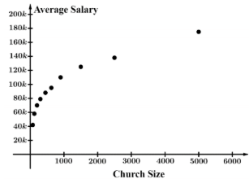

The table below gives the data from the graph (from above) relating church size and average salaries for pastors in the United States. 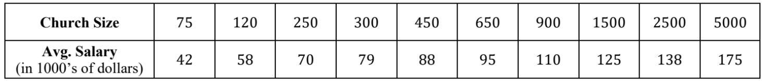
- Use the regression capabilities of your graphing calculator to find a logarithmic function model for the data above of the form $S(p)=a+bln(p)$, where $p$ represents the church size and $S$ is the average pastor salary in thousands of dollars.

- Using the model found in part a, what is the predicted annual salary, in thousands of dollars, for a pastor whose church size is 500 people?

Example 2: Selected values of the logarithmic function $L$ are given below, where $L(x)=a+blnx$. It is known that $L(2)=3$ and $L(5)=7$
- Use the given data to write two equations that can be used to find the values for constants $a$ and $b$ in the expression $L(x)$.
- Find the values of $a$ and $b$.
Example 3: The most common, and preferred, method to measure sound intensity levels is in decibels (dB). The sound intensity level $β$ (in decibels) of a sound having intensity I (in watts per meter squared) is modeled by the function $β(I)=a+blog(I)$, where $a$ and $b$ are constants. The sound of noisy traffic has intensity $1×10^{-5}$ watts per meter squared and corresponds to 70 decibels. A loud concert has intensity of $1$ and corresponds to $120$ decibels.
- Use the given data to write two equations that can be used to find the values for constants $a$ and $b$ in the expression for $β(I)$.
- Find the values of $a$ and $b$.
- The human eardrum can burst when sounds reach an intensity level of $1×10^{4}$ watts per meter squared. According to the model found above, what is the predicted number of decibels required to burst a human eardrum?

Unit 2 - Exponential & Logarithmic Functions
2.15 Semi Log Plots

Example 1: The table below gives selected values for the function $f$. Which of the following graphs could represent these data in a semi-log plot, where the vertical axis is logarithmically scaled?
$x$ | $1$ | $2$ | $3$ | $4$ | $5$
$f(x)$ | 40 | 60 | 90 | 135 | 203

- 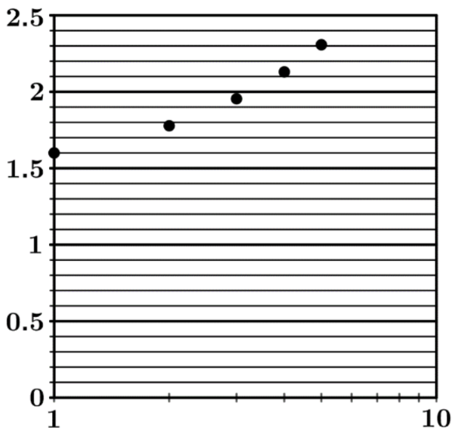 | - 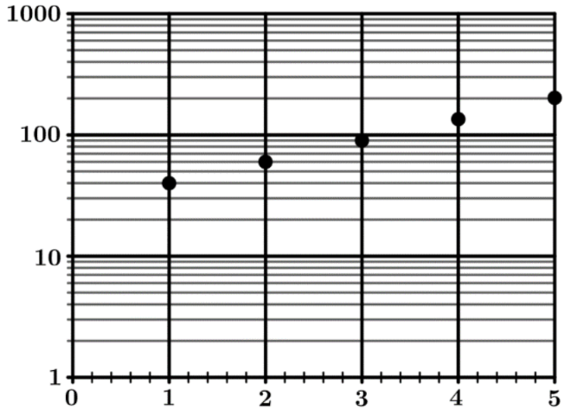
- 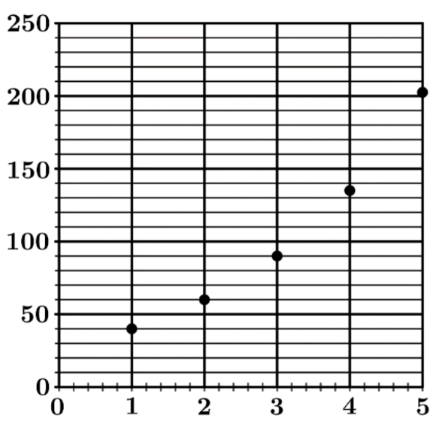 | - 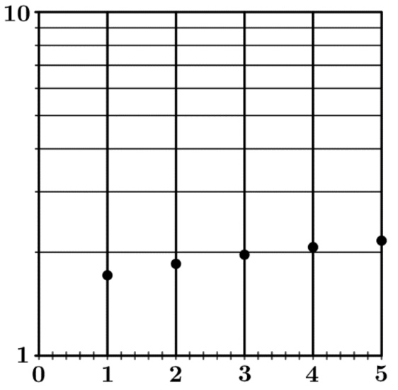

Example 2: Use the graph & data from Example 1.
- Write an equation for the linear model for the semi-log plot of the form $y=(log_{n}b)x+log_{n}a$.
- Using the linear model from part a, write the equation of the exponential model $y=ab^{x}$ for this data.
Example 3: After Justin Bieber releases his new album, the number of people $P$ that have heard his album after $t$ hours is graphed on the semi-log plot above where the vertical axis has been logarithmically scaled. Which of the following functions could be a model for $P$?
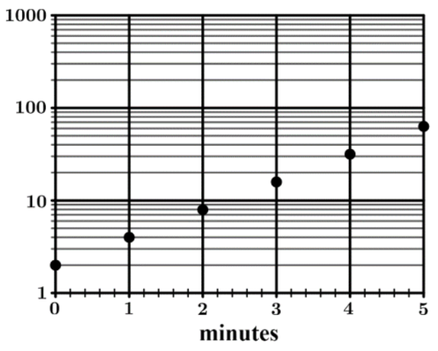 | - $P(t)=2+2t$  - $P(t)=2+2^{t}$  - $P(t)=2+log_{2}t$  - $P(t)=2(2)^{t}$

